PRACTICAL 7

190030480

G.Yasaswini

1). Open Git bash terminal and create one new directory as junit4

For creating new directory

mkdir junit4

cd junit4

So clone the repository for junitfiles(bin files, testsrc files and src files) to run in eclipse

2). copy the ssh path of the created project in github

Apply git clone command

In git bash type pwd

i.e present working directory

3).open eclipse

Welcome dashboard in eclipse and click on close (marked as yellow)

Click on file and click on open projects from file system

Now copy the path from git bash

Now we need import project from folder junit4

Click on directory

Select folder junit4

4).Click finish

Click on TDDwithoutJUnit

Right click on junit4 and select Build path-> remove from build path

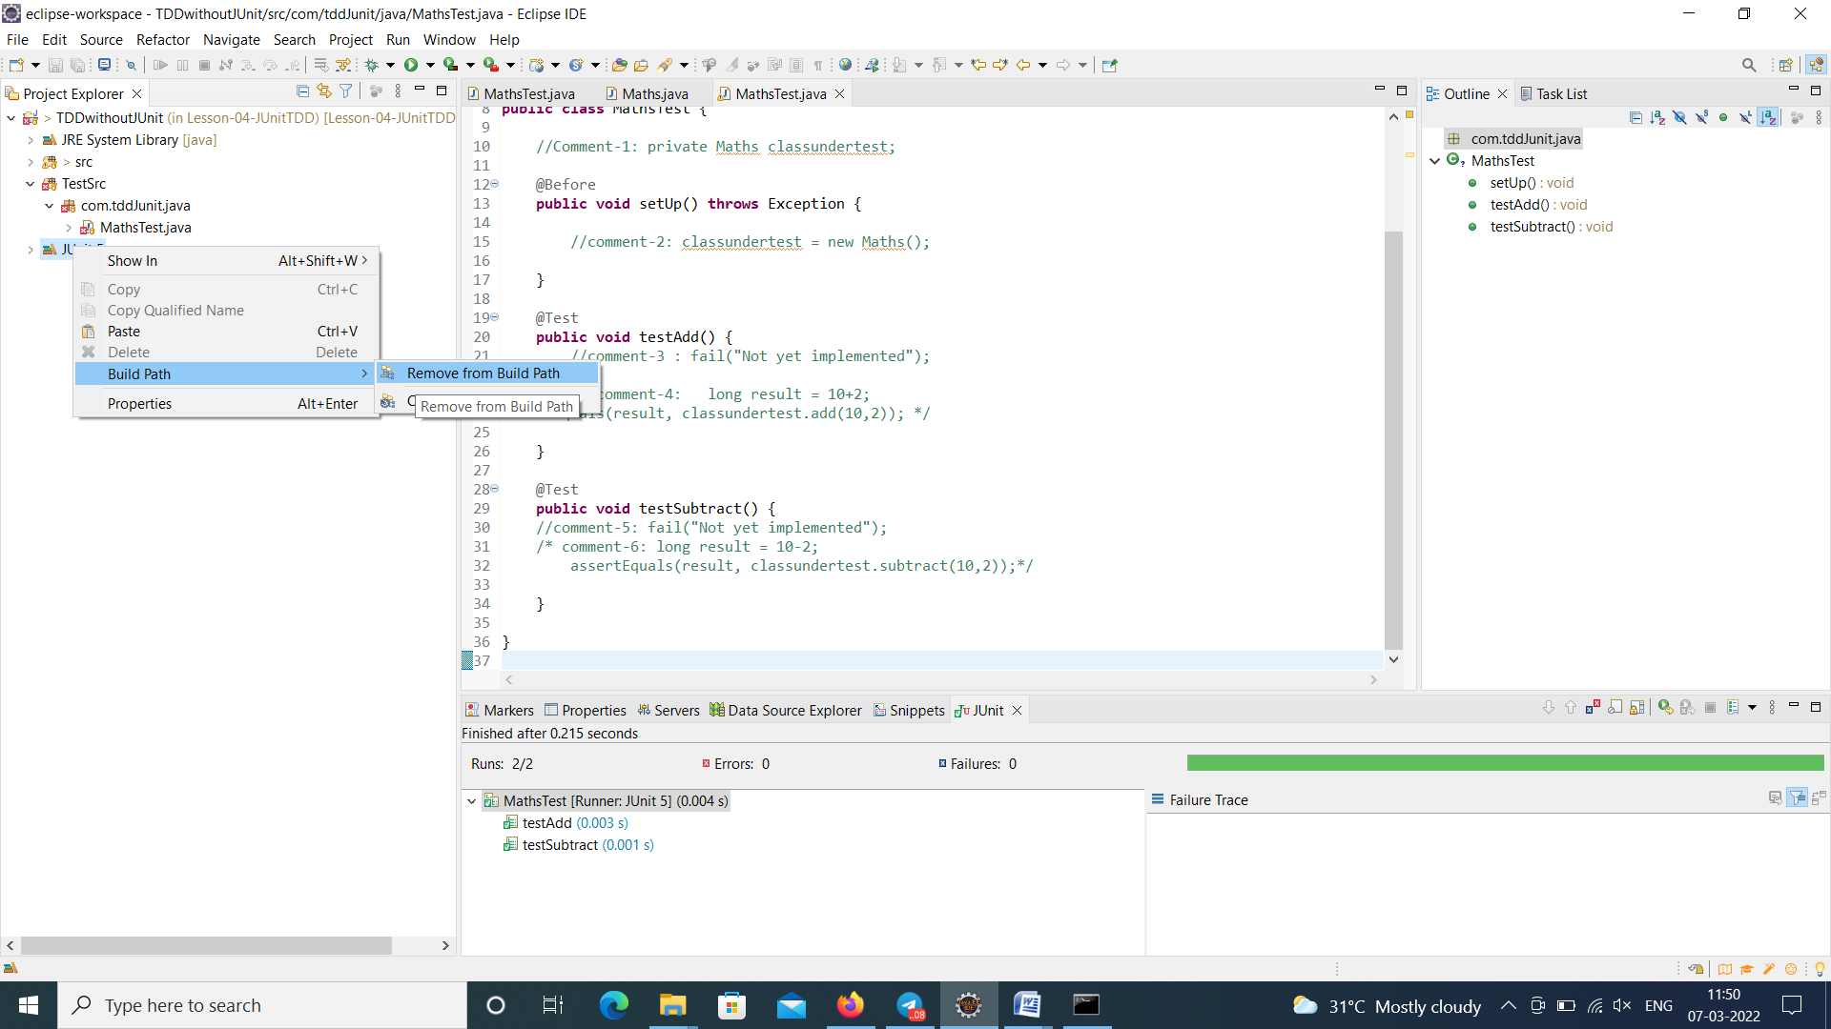

Junit4 folder was removed completely

5). Go to TestSrc folder and then com.tdd.junit.java and in we have MathsTest.java

Copy entire code in MathsTest.javaand paste it in notepad and save the notepad for temporarily and delete com.tdd.junit.java package

6). Gotosrcdirectory and right click onMaths.java.

Select New and then Junit Test case

7). It will generate a test file in the **TestSrc** directory and JUnit 5 libraries in the project. Do not change any files in the JUnit 5 libraries.

Run the **MathsTest.java**file, and confirm that the test cases will fail.

To run the MathsTest.java (Right click on code)

8).Test fail results

Now, replace the existing code with the codes saved in the temporary file(**MathsTest.java** file)

Copy the code and paste it MathsTest.java file

9).save the file

Run the file

No errors

